Instruction: This is a group task.
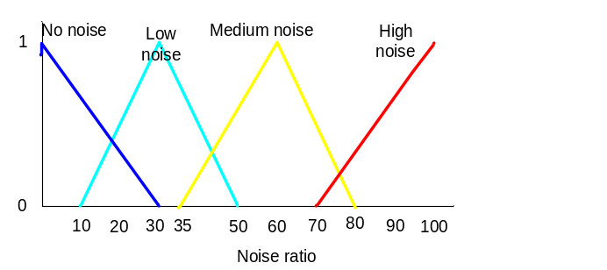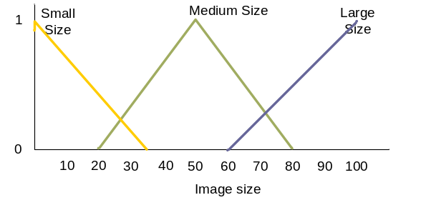
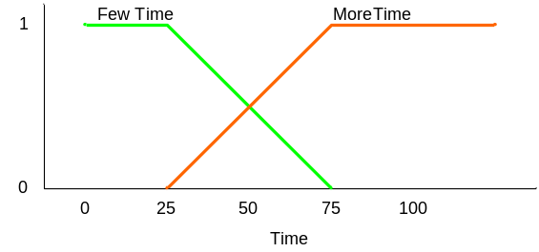

Figure 1: The system specification
IF Medium size AND No noise THEN few Time
IF Small size AND Low noise THEN few Time
IF Large size AND Low noise THEN few Time
IF Large size AND Medium noise THEN Long Time
IF Medium Load AND High noise THEN Long Time
Figure 2: New problem
Task:-
- Use Matlab Software to do this lab sheet using the Figure 1.
- Use Fazzy logic, to find a solution for the new problem when the image size is 30mp and the image noise is 45dB.
- Use the proper roles to support your solution in Figure 2.
- Find out the output for this problem ,
- Select TWO other points in the input and show the output for the new selections.
- Print Screen the input as well as the output and the roles in your report then submit it in the link available in the moodel.
- Submission Date : End of Lab Session

Answer:

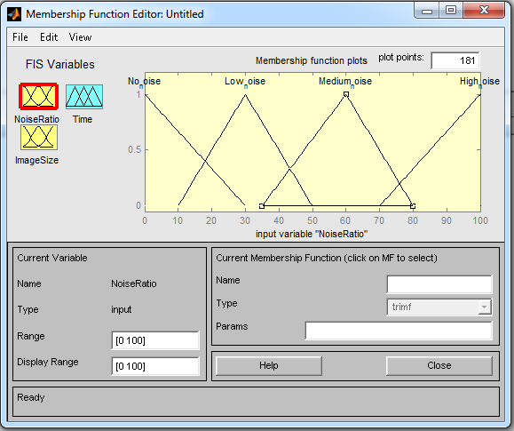
This is the membership function for noise ratio.

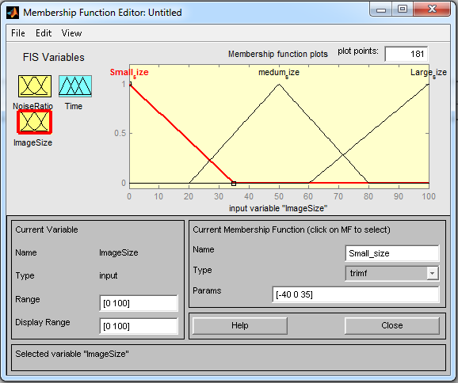

This is the membership function for image size.

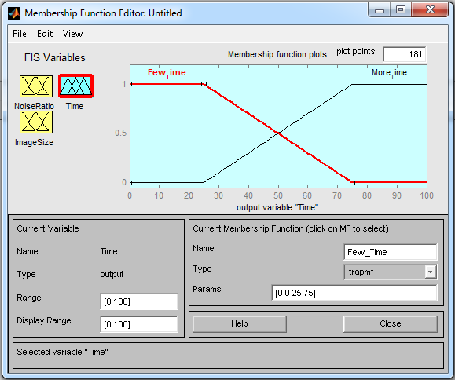

This is the output of the time.

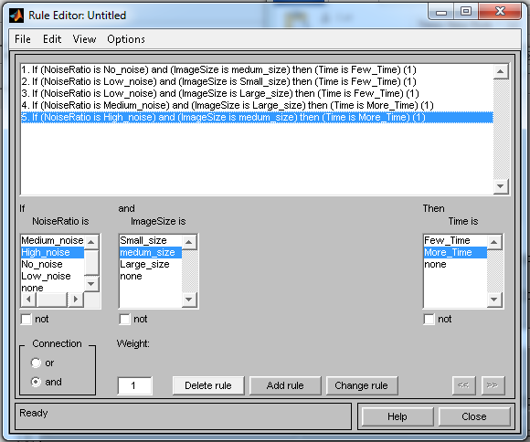

This is the rule based that have been given to find the suitable rule to get the fuzzy value that given.

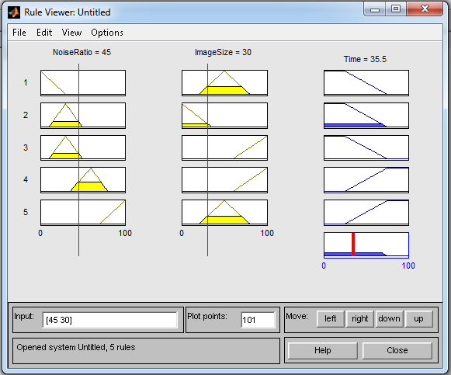

The input is {image size: 30, image noise: 45}.
- Initialize the fuzzy value based on the membership function
- Calculate the input value based on the fuzzy value.

- Determine the degree of membership:
Low(0.25) /\ Small(0.143) = 0.143
Based on the fuzzy logic connectives, /\ is the fuzzy conjunction, so take the minimum value.
- Choose the rule based that have the both variable same as the input value.
IF Small size AND Low noise THEN few Time.

- Lastly, find the centroid where the location membership is 100%.

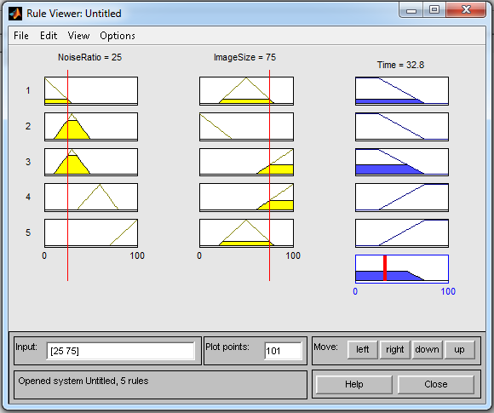

This is the second input which is {noise ratio:25, image size:75}.
So, based on the step we stated at previous page, we get the output is 32.8.

